ELIZABETH SUTHERLAND SCHOOL
66 Rockingstone Road, Halifax, NS, B3R 2C9
https://els.hrce.ca
ess@hrce.ca
Phone 479-4427
Fax 479-4430

Sara Walker – Principal
Craig Nelson – Vice-Principal



WEEKLY SKYHAWK UPDATES

Administrators’ Message

Spring is finally in the air and I’m sure we are all happy for the return of warmer weather! Teachers are taking their students outside more often now to use our outdoor classroom. If possible, it’s good for the students to have a water bottle at school so that they can keep it filled at their desk and take it outside with them.

We understand that students are getting excited about summer vacation and that they have been patient and cooperative with the COVID protocols that have impacted three school years. We still have 7 more weeks of this school year so we are reminding them to continue to come to school with a positive mindset and the materials that they need for class.

We hope you all have a wonderful week.

Clubs and Sports

Stronger Together Fitness Group – Monday and Wednesday 8:00 am – 9:00 am for girls in grades 7-8.

Sketch Club – Grade 3 and 4 on Wednesday at lunch week 1; Grade 5 and 6 on Wednesday at lunch week 2; Grade 7 and 8 Thursday at lunch.

Dungeons and Dragons – Grade 6-8 from 3:00 – 4:30 on Wednesdays Week 1. This group is already full.

GSA (Gender Sexuality Alliance) – Tuesdays at lunch for Grades 5-8

Climate Action Club – Grade 5 on Thursdays from 3:00 – 3:45.

Open Gym – Thursday and Friday from 8:00 am – 9:00 am for grades 4-8.

Sports Teams – Sign up sheets are generally up several weeks before try-outs and coaches provide students with regular reminders. They are also reminded in their physical education classes and on the morning announcements. Our coaches also post on Twitter, which is linked to our school Twitter account that can be seen on our school website.

Outdoor Recreation Fundraising Committee

Now that we can begin fundraising projects again, we are ready to move forward with plans for outdoor recreation equipment for our school. In the coming weeks, representatives from HRCE and HRM will be visiting the school to help us decide where equipment can be placed and what kind of equipment we can have on the grounds. Once those decisions are made, we will have an idea of how much we need to fundraise. I will continue to include updates in the weekly messages.

Outdoor Classroom

Our Outdoor Classroom is complete and we have had perfect weather this past week for putting it to good use!

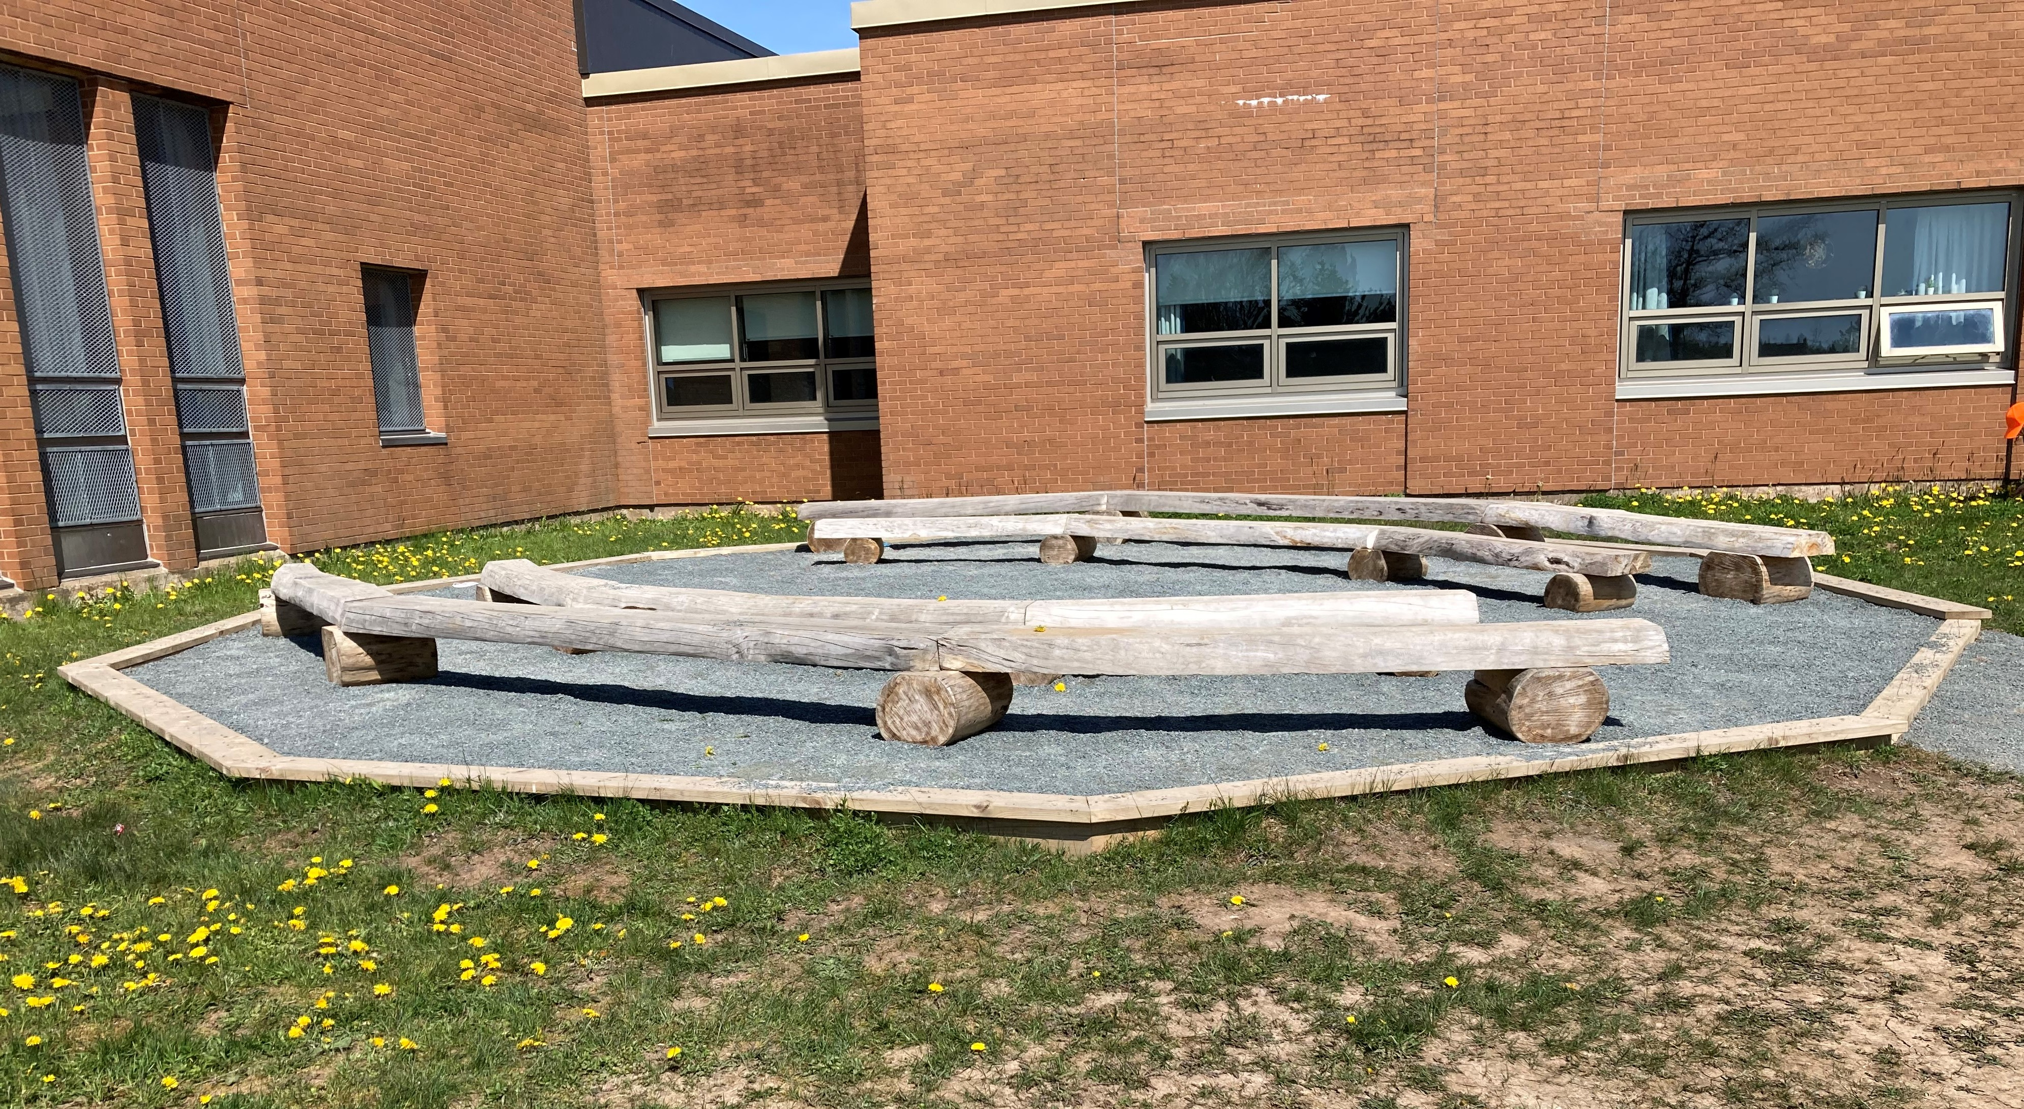

Dropping Off and Picking Up Students Throughout the Day

Teachers often take their students outside at various times of the day so when dropping off or picking up students throughout the day, please use the 15-minute parking spaces on the road and do not drive up onto the school grounds. Thank you.

Criminal Records/Vulnerable Sector Checks and Child Abuse Registry Paperwork

If you are obtaining a criminal record check and child abuse check to chaperone on a field trip, it is easiest if you contact Mrs. Parker so that she can invite you to our school account in myBackCheck.com. This way, we can be sure that all the necessary paperwork is completed.

Attendance/Safe Arrival

Please remember to call safe arrival (479-4427) when your child is going to be absent from school. Emails to teachers are not always seen before safe arrival calls begin and if the teacher is absent, the office may not get the message. Messages can be left 24 hours a day, 7 days a week. The office is very busy first thing in the morning so having the safe arrival messages helps us get through the absences in a timely manner.

Unlike some other schools, we do not have the multiple phone lines in our school. If you call the school and you do not get an answer, please leave a message. When Mrs. Parker is doing safe arrival in the mornings, it is very busy and she cannot answer every call as it comes in. The safe arrival message line is Mrs. Parker’s line so you will get her recorded message when you call. Thank you for your patience and understanding.

Primary Orientation

Primary Orientation will be on Friday afternoon May 27th from 1:30 – 2:30. Staff, students, and families will all meet in the library for introductions then the students will spend some time with the teachers while the families stay in the library for a short presentation and time for questions. Current primary students will spend the afternoon with their reading buddies.

Grade 8 Closing

We will be having a grade 8 closing on Tuesday June 28th. We will be providing lunch for the students and having a casual awards celebration either before or after lunch. We are still finalizing a few details so those will be posted in the next memo home. This is not a formal graduation ceremony, but we will be welcoming families to join us for cake and pictures.

Upcoming Important Dates

May 16th – 27th – During this block of time, the grade 3 students will be writing the provincial literacy and math assessment.

May 24th – June 3rd – During this block of time, the grade 8 students will be writing the provincial Reading/Writing/Math Assessment.

May 27th – Primary Orientation 1:30.

June 7th - Orientation for incoming Elementary French Immersion Students and Families (6:00 – 7:00 pm) and all Junior High Students and Families (7:30 – 8:30 pm).

June 28th – Grade 8 Closing

June 29th - Assessment and Evaluation Day. No school for students.

June 30th – Last day of school.

